**Unreal Engine – sample project - Levels**

This project is a simple prototype, using imported FBX objects from Blender, GameInstance object to save score value between levels, Sequence on changing level, user interface with using external images and also having separate game logics for each level, which are defined in GameMode.

Each item on stage, have a tag as “**One**”, “**Two**”, “**Three**”, and “**Next Level**”. These tags are using to address triggers on stage and inventory items in widget. Item with tag “**Next Level**” always activate the “BP_Gate” object which is visualized by “Sequencer” inside each level. This object will switch levels on player collision event.

*Note: if you are using “Sequencer”:  
First make your sequencer,   
then make a public variable on your blueprint and then,   
drag and drop sequencer in stage and pick up sequencer for your public variable.*

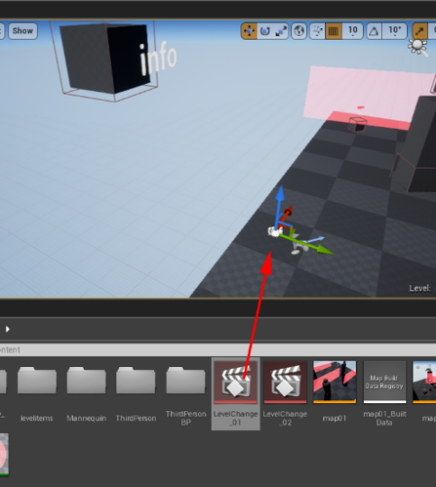 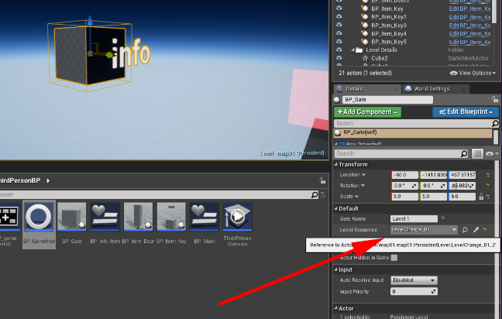

Total score is an integer inside “BP_GameInst”, this blueprint is made from Game Instance class.

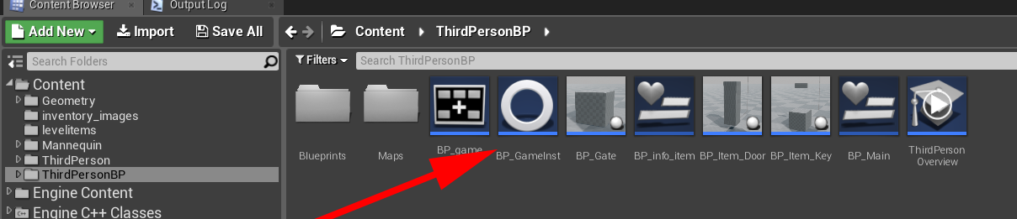

Game Instance class prepare access to **static data** across levels for your game.

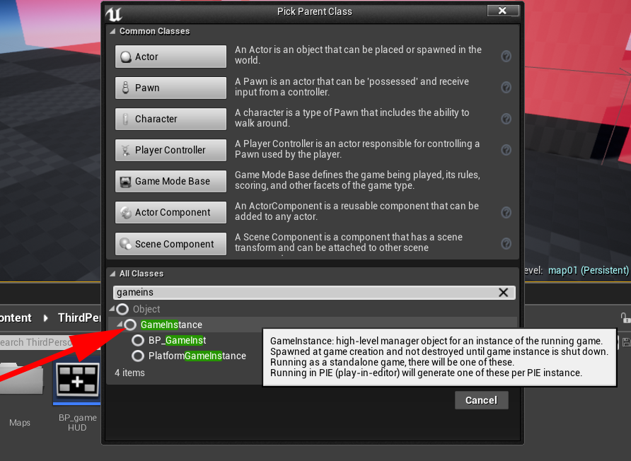

Also, this class need to be set in project setting of your game. Navigate to **project setting>maps** and in there, search for **game instance**, and then choose your own game instance class.

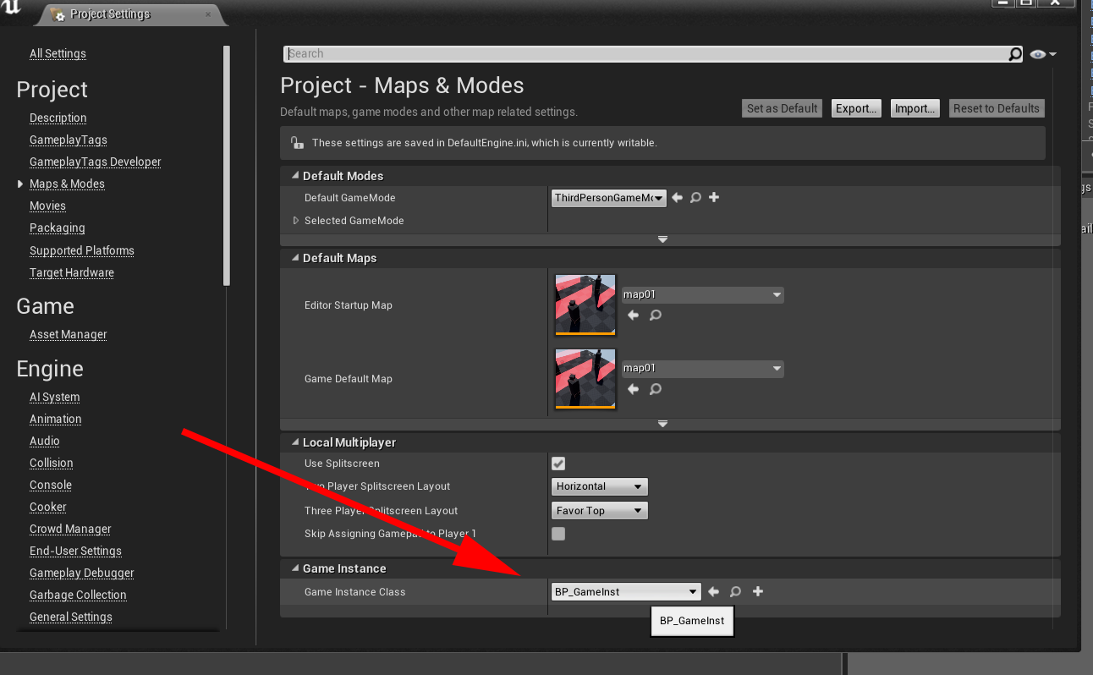

… more in depth with Unreal Engine Sequencer:

Basic:

https://www.youtube.com/watch?v=wYoTusZ2X5g

https://www.youtube.com/watch?v=tYPe-C6VDVo

Details:

Cinematics with Sequencer | Epic Games (01-12)

https://www.youtube.com/watch?v=uEnfMV-4afA&list=PLZlv_N0_O1gaiA_sfpjATUprVW7B9FcK1

----- Lynda.com ------

- Unreal Engine: Product Visualization

5. Building a Cinematic

- Unreal: Architectural & Industrial Visualization

9. Camera Animation with Sequencer

- Unreal: CAD Data Visualization

5. UE4 Sequencer and CAD Visualization